**2023 Wild & Scenic Film Festival Film Synopses**

**Finding Salmon –** Follow 11-year-old, Keyona, into a wondrous world of trees, water, and friendly fish... and find the spirit of Salmon Watch, a program that connects Oregon youth to their backyard river ecosystems.

**One Star Reviews –** They say National Parks are America's greatest idea. Some of the most beautiful and sacred places in all the world. Well, for some people... there's still room for improvement!

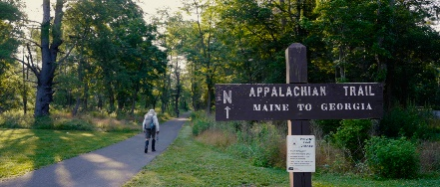**The Last Last Hike** – 83-year-old Nimblewill Nomad is about to become the oldest person to thru-hike the Appalachian Trail.

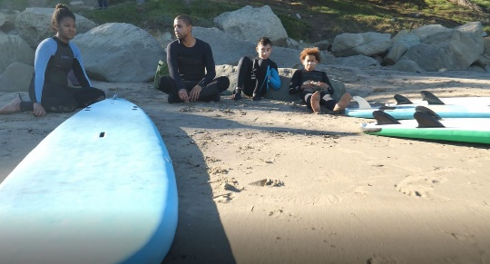**Black Like Plastic—Nature, Culture, and People** – Black Like Plastic highlights some of the inequities that exist in the Black community in relation to the environment. Chris Ragland, founder of The Sea League, narrates the film bringing to light the connection between access, outdoor recreation, and advocacy.

**Land of the Yakamas** – "Land of the Yakamas" is a short film that focuses on the importance of the ancestral lands surrounding the general Nch’i-Wàna (Columbia River) area, as well as some of the environmental challenges the communities of the region face.

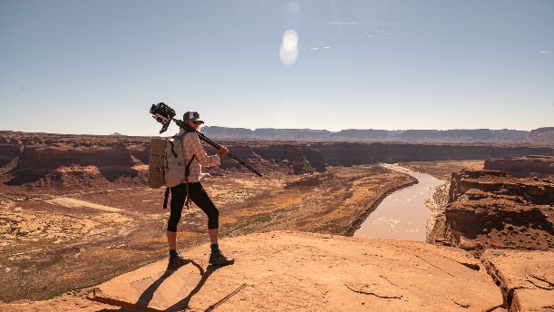**Tad's Emerging World - Glen Canyon Exposed** – Glen Canyon is a hidden treasure of the Southwest and is now emerging. This epic landscape is under a failing reservoir called Lake Powell from the construction of the Glen Canyon Dam in 1963. Photographer, Dawn Kish, is going on an adventure to explore and document this exposed landscape with a camera that captured Glen Canyon pre-dam by the legendary photographer, Tad Nichols. What will develop?

**I Am Salmon** – Connecting humanity with salmon and the sea through the subtle art of poetry and Gyotaku (fish rubbing), Duncan Berry shares his experience as a longtime environmentalist and former captain of a salmon troller. In adopting the perspective of this transcendent fish, the beauty and power of the Oregon coast becomes the canvas through which the evolution of the salmon is illustrated.

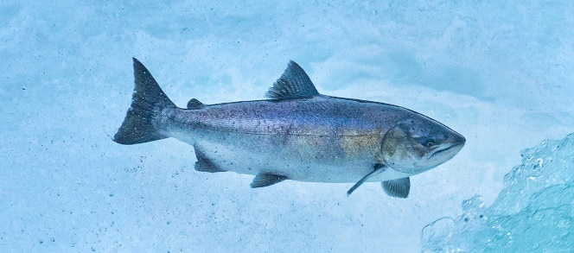**The Lost Salmon** – The Lost Salmon' chronicles the plight and potential recovery of the iconic Spring-run Chinook Salmon of the Pacific Northwest. Faced with extinction in many river systems of the West, a new genetic discovery could aid in their recovery. Once teeming in the millions and a sacrament for the oldest civilizations in the Americas, time is running out for this genetically distinct wild salmon.